##### <Guest> Register

**Use Case Diagram**

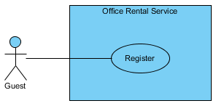

Figure ??: <Guest> Register

**Use Case Specification**

|  |  |  |  |  |
| --- | --- | --- | --- | --- |
| **USE CASE – REGISTER** | | | | |
| **Use-case No.** | UC001 | **Use-case Version** | | 2.0 |
| **Use-case Name** | Register | | | |
| **Author** | Trương Tiến Thành | | | |
| **Date** | 20/07/2015 | **Priority** | Normal | |
| **Actor:**   * Guest.   **Summary:**   * This use case allows guest create account.   **Goal:**   * Help guest to create new account.   **Trigger:**   * Click “Đăng ký” button.   **Pre-conditions:**   * N/A.   **Post conditions:**   * **Success**: The new account will be added into database. * **Failure**: Cannot create account. System displays error message.   **Main Success Scenario:**   |  |  |  | | --- | --- | --- | | Step | Actor Action | System Response | | 1 | Click “Đăng ký” button. | System show [Register pop-up], contain a register form:   * Tên đăng nhập (*): Textbox (min length: 3, max length: 50).   [Exception 1, 9, 10]   * Mật khẩu (*): Password Filed (min length: 8, max length: 20).   [Exception 2, 10]   * E-mail (*): Textbox (max length: 30).   In e-mail format.  [Exception 3, 10]   * Xưng hô: drop-down list. * Họ và tên (*): Textbox (min length: 6, max length: 50).   [Exception 4, 10]   * Công ty: Textbox (max length: 50).   [Exception 5]   * Số điện thoại (*): Textbox (min length: 10, max length: 10).   In format: /^[0-9]*$/  [Exception 6, 10]   * Địa chỉ: Textbox (max length: 100).   [Exception 7]   * Ngày sinh: Date time picker.   [Exception 8]   * Captcha: Checkbox. * Đăng ký: Button. * Hủy: Button. | | 2 | Input information.  Clicks “Đăng ký” button.  [Alternative 1] | Close [Register pop-up] and displays message:”Đăng kí thành công. Mời đăng nhập và kiểm tra email để hoàn tất đăng kí”. |   **Alternative Scenario:**   |  |  |  | | --- | --- | --- | |  | Actor Action | System Response | | 1 | Click on the “Hủy” button. | Close [Register pop-up]. |   **Exceptions:**   |  |  |  | | --- | --- | --- | | No. | Actor Action | System Response | | 1 | “Tên đăng nhập” is less than 3 or more than 50 characters. | Display error message “Nhập ít nhất 3 ký tự” or “Số ký tự tối đa là 50”. | | 2 | “Mật khẩu” is less than 8 or more than 20 characters. | Display error message “Nhập ít nhất 8 ký tự” or “Số ký tự tối đa là 20”. | | 3 | “E-mail” is more than 30 characters. | Display error message “Số ký tự tối đa là 30”. | | 4 | “Họ và tên” is less than 6 or more than 50 characters. | Display error message “Nhập ít nhất 6 ký tự” or “Số ký tự tối đa là 50”. | | 5 | “Công ty” is more than 50 characters. | Display error message “Số ký tự tối đa là 50”. | | 6 | “Số điện thoại” is not a number or less than 10 numbers or greater than 11 numbers. | Display error message “Nhập ít nhất 10 ký tự” or “Số ký tự tối đa là 11”. | | 7 | “Địa chỉ” is greater than 100 characters. | Display error message “Số ký tự tối đa là 100”. | | 8 | “Ngày sinh” is invalid. | Display error message “Ngày không hợp lệ”. | | 9 | “Tên đăng nhập” exist in database. | Display message “Tên đăng nhập đã được sử dụng. Hãy chọn tên khác”. | | 10 | “Tên đăng nhập”, “Mật khẩu”, “E-mail”, “Họ và tên”, “Số điện thoại” are empty. | Display error message “Bắt buộc”. |   **Relationships:** N/A.  **Business Rules**:   * The role of new created account is “Customer” and status is “Normal”. * Username must be different from existed username in system. | | | | |

Table ??: <Guest> Register

##### <Guest> Login

**Use Case Diagram**

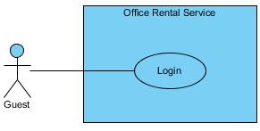

Figure ??: <Guest> Login

**Use Case Specification**

|  |  |  |  |  |
| --- | --- | --- | --- | --- |
| **USE CASE – LOGIN** | | | | |
| **Use-case No.** | UC002 | **Use-case Version** | | 2.0 |
| **Use-case Name** | Login | | | |
| **Author** | Trương Tiến Thành | | | |
| **Date** | 20/07/2015 | **Priority** | Normal | |
| **Actor:**   * Guest   **Summary:**   * This use case allows user to login to website.   **Goal:**   * Guest can login to website.   **Triggers:**   * Click “Đăng nhập” button on menu bar.   **Preconditions:**   * Guest already has an account on website.   **Post Conditions:**   * **Success:** Guest successfully login into the website. * **Failure:** Guest cannot login.   **Main Success Scenario:**   |  |  |  | | --- | --- | --- | | Step | Actor Action | System Response | | 1 | Click “Đăng nhập” button. | System show [Login pop-up], contain a login form:   * Tên tài khoản: Textbox.   [Exception 1]   * Mật khẩu: Password Filed.   [Exception 2]   * Giữ trạng thái đăng nhập: Checkbox. * Quên mật khẩu: Link. * Đăng nhập: Button.   [Exception 3, 4]   * Hủy: Button. | | 2 | Input username and password.  Click “Đăng Nhập” button.  [Alternative 1, 2, 3] | Close [Login pop-up] and show message “Đăng nhập thành công”. |   **Alternative Scenario:**   |  |  |  | | --- | --- | --- | |  | Actor Action | System Response | | 1 | Click “Giữ trạng thái đăng nhập” checkbox, then click “Đăng Nhập” button. | Close [Login pop-up] and show message “Đăng nhập thành công”. | | 2 | Click “Quên mật khẩu” link. | (Bổ sung sau) | | 3 | Click “Hủy” button. | Close [Login pop-up]. |   **Exceptions:**   |  |  |  | | --- | --- | --- | | No. | Actor Action | System Response | | 1 | “Tên tài khoản” is empty. | Display error message “Vui lòng nhập tên đăng nhập”. | | 2 | “Mật khẩu” is empty. | Display error message “Vui lòng nhập mật khẩu”. | | 3 | Cannot login due to database connection. | Display error message “Có lỗi xảy ra. Xin thử lại”. | | 4 | “Tên tài khoản” or “Mật khẩu” not correct. | Display error message “Tên đăng nhập hoặc mật khẩu không chính xác, xin thử lại”. |   **Relationships:** N/A  **Business Rules:**   * Guest can only login in website and cannot login in system page. * Staff, manager and admin can’t login in website. | | | | |

Table 2: <Guest> Login

##### <Customer> View customer info

**Use Case Diagram**

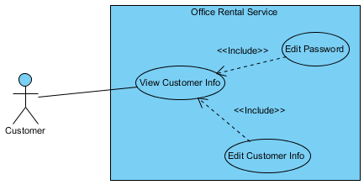

Figure ??: <Customer> View customer info

**Use Case Specification**

|  |  |  |  |  |
| --- | --- | --- | --- | --- |
| **USE CASE – VIEW CUSTOMER INFO** | | | | |
| **Use-case No.** | UC003 | **Use-case Version** | | 2.0 |
| **Use-case Name** | View customer Info | | | |
| **Author** | Trương Tiến Thành | | | |
| **Date** | 20/07/2015 | **Priority** | Normal | |
| **Actor:**   * Customer.   **Summary:**   * This use case allows customer view customer information.   **Goal:**   * Show profile of customer.   **Triggers:**   * Click “Thông tin cá nhân” in drop-down menu.   **Preconditions:**   * User must login in customer role.   **Post Conditions:**   * **Success**: Customer information is showed successfully. * **Fail:** Cannot view customer information.   **Main Success Scenario:**   |  |  |  | | --- | --- | --- | | Step | Actor Action | System Response | | 1 | Click “Thông tin cá nhân” in drop-down menu. | Show customer information.  Display customer details includes:   * Xưng hô: Text * Họ và tên: Text * Công ty: Text * Số điện thoại: Text * Địa chỉ: Text * Ngày sinh: Text * Sửa thông tin: Button * Sửa mật khẩu: Button |   **Alternative Scenario:**   |  |  |  | | --- | --- | --- | | No. | Actor Action | System Response | |  |  |  |   **Exceptions:**   |  |  |  | | --- | --- | --- | | No. | Actor Action | System Response | |  |  |  |   **Relationships:** Edit customer info.  **Business Rules:**   * Customer information must exist in database. | | | | |

Table ??: <Customer> View customer info

##### <Customer> Edit customer info

**Use Case Diagram**

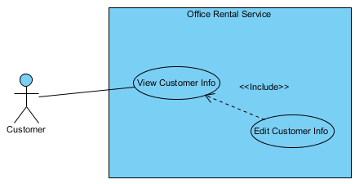

Figure 10: <Customer> Edit customer info

**Use Case Specification**

|  |  |  |  |  |
| --- | --- | --- | --- | --- |
| **USE CASE – EDIT CUSTOMER INFO** | | | | |
| **Use-case No.** | UC004 | **Use-case Version** | | 2.0 |
| **Use-case Name** | Edit customer info | | | |
| **Author** | Trương Tiến Thành | | | |
| **Date** | 20/07/2015 | **Priority** | Normal | |
| **Actor:**   * Customer   **Summary:**   * This use case allows customer edit information.   **Goal:**   * Customer can edit information.   **Triggers:**   * Click “Thông tin cá nhân” in drop-down menu. * Click “Sửa thông tin” button.   **Preconditions:**   * Customer must be login.   **Post Conditions:**   * **Success**: customer information is edited successfully. * **Fail:** Cannot edit customer information.   **Main Success Scenario:**   |  |  |  | | --- | --- | --- | | Step | Actor Action | System Response | | 1 | Click “Sửa thông tin” on the screen. | Show customer information, includes:   * Họ và tên (*): Textbox.   [Exception 1, 6]   * Công ty: Textbox.   [Exception 2]   * Số điện thoại (*): Textbox.   [Exception 3, 6]   * Địa chỉ Email: Textbox.   [Exception 4]   * Ngày sinh: Textbox.   [Exception 5]   * Chỉnh sửa: Button. * Hủy: Button. | | 2 | Click “Chỉnh sửa” button.  [Alternative 1] | Show message “Chỉnh sửa thành công” and return to [Profile page]. |   **Alternative Scenario:**   |  |  |  | | --- | --- | --- | | No. | Actor Action | System Response | | 1 | Click “Huỷ” button. | Return to [Profile page]. |   **Exceptions:**   |  |  |  | | --- | --- | --- | | No. | Actor Action | System Response | | 1 | “Họ và tên” is less than 6 or more than 50 characters. | Display error message “Nhập ít nhất 6 ký tự” or “Số ký tự tối đa là 50”. | | 2 | “Công ty” is more than 50 characters. | Display error message “Số ký tự tối đa là 50”. | | 3 | “Số điện thoại” is not a number or less than 10 numbers or greater than 11 numbers. | Display error message “Nhập ít nhất 10 ký tự” or “Số ký tự tối đa là 11”. | | 4 | “Địa chỉ” is more than 100 characters. | Display error message “Số ký tự tối đa là 100”. | | 5 | “Ngày sinh” is invalid. | Display error message “Ngày không hợp lệ”. | | 6 | “Họ và tên” or “Số điện thoại” is empty. | Display error message “Bắt buộc”. |   **Relationships:** View customer info  **Business Rules:**   * Only customer can edit information. | | | | |

Table ??: <Customer> Edit customer info

##### <Customer> Change password

**Use Case Diagram**

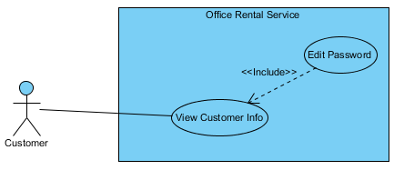

Figure 10: <Customer> Change password

**Use Case Specification**

|  |  |  |  |  |
| --- | --- | --- | --- | --- |
| **USE CASE – CHANGE PASSWORD** | | | | |
| **Use-case No.** | UC005 | **Use-case Version** | | 2.0 |
| **Use-case Name** | Change password | | | |
| **Author** | Trương Tiến Thành | | | |
| **Date** | 20/07/2015 | **Priority** | Normal | |
| **Actor:**   * Customer   **Summary:**   * This use case allows customer change password.   **Goal:**   * Customer can change password.   **Triggers:**   * Click “Thông tin cá nhân” in drop-down menu. * Click “Sửa mật khẩu” button.   **Preconditions:**   * Customer must be login.   **Post Conditions:**   * **Success**: password of customer is changed successfully. * **Fail:** Cannot change password.   **Main Success Scenario:**   |  |  |  | | --- | --- | --- | | Step | Actor Action | System Response | | 1 | Click “Sửa mật khẩu” on the screen. | Show information, includes:   * Mật khẩu hiện tại: Password field.   [Exception 1, 4]   * Mật khẩu mới: Password field.   [Exception 2, 4]   * Nhập lại mật khẩu mới: Password field.   [Exception 3, 4]   * Chỉnh sửa: Button. * Hủy: Button. | | 2 | Click “Chỉnh sửa” button.  [Alternative 1] | Show message “Chỉnh sửa thành công” and return to [Profile page]. |   **Alternative Scenario:**   |  |  |  | | --- | --- | --- | | No. | Actor Action | System Response | | 1 | Click “Huỷ” button. | Return to [Profile page]. |   **Exceptions:**   |  |  |  | | --- | --- | --- | | No. | Actor Action | System Response | | 1 | “Mật khẩu hiện tại” is less than 8 or more than 20 characters. | Display error message “Nhập ít nhất 8 ký tự” or “Số ký tự tối đa là 20”. | | 2 | “Mật khẩu mới” is less than 8 or more than 20 characters. | Display error message “Nhập ít nhất 8 ký tự” or “Số ký tự tối đa là 20”. | | 3 | “Nhập lại mật khẩu mới” is less than 8 or more than 20 characters. | Display error message “Nhập ít nhất 8 ký tự” or “Số ký tự tối đa là 20”. | | 4 | “Mật khẩu hiện tại”, “Mật khẩu mới” or “Nhập lại mật khẩu mới” is empty. | Display error message “Bắt buộc”. |   **Relationships:** View customer info  **Business Rules:**   * Only customer can change password. | | | | |

Table ??: <Customer> Change password

##### <Customer> Create appointment request

**Use Case Diagram**

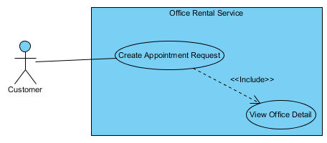

Figure ??: <Customer> Create appointment request

**Use Case Specification**

|  |  |  |  |  |
| --- | --- | --- | --- | --- |
| **USE CASE – CREATE APPOINTMENT REQUEST** | | | | |
| **Use-case No.** | UC006 | **Use-case Version** | | 2.0 |
| **Use-case Name** | Create appointment request | | | |
| **Author** | Trương Tiến Thành | | | |
| **Date** | 20/07/2015 | **Priority** | Normal | |
| **Actor:**   * Customer.   **Summary:**   * This use case allows customer request appointment.   **Goal:**   * Customer can request appointment after they found suitable office.   **Trigger:**   * After choosing suitable office, click “Gửi yêu cầu”. * Input time and click “Đặt lịch hẹn”.   **Pre-conditions:**   * User must log in the system with customer role.   **Post conditions:**   * **Success:** Request appointment successful. * **Fail:** Show message error and show which information error.   **Main Success Scenario:**   |  |  |  | | --- | --- | --- | | Step | Actor Action | System Response | | 1 | Click “Gửi yêu cầu” button. | Redirect to [Request office page], contain:   * Thời gian [?]: Date time picker. * Đặt lịch hẹn: Button.   [Exception 1]   * Hủy: Button. | | 2 | Input date and time.  Click “Đặt lịch hẹn” button.  [Alternative 1] | Return to [Detail office page] and displays message:”Đặt lịch hẹn thành công”. |   **Alternative Scenario:**   |  |  |  | | --- | --- | --- | |  | Actor Action | System Response | | 1 | Click “Hủy” button. | Return to [Detail office page]. |   **Exceptions:**   |  |  |  | | --- | --- | --- | |  | Actor action | System Response | | 1 | “Thời gian” is empty | Displays error message:”Không thành công. Có lỗi xảy ra, xin thử lại”. |   **Relationships:** View office detail.  **Business Rules**:   * Customer can request appointment which offices have status available. * Valid time from 8 am to 6 pm. * Valid date from Monday to Friday. | | | | |

Table ??: <Customer> Create appointment request

##### <Customer> View rental request list

**Use Case Diagram**

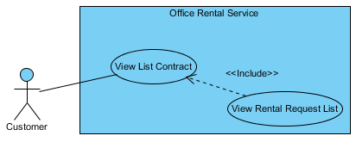

Figure ??: <Customer> View rental request list

**Use Case Specification**

|  |  |  |  |  |
| --- | --- | --- | --- | --- |
| **USE CASE – VIEW RENTAL REQUEST LIST** | | | | |
| **Use-case No.** | UC007 | **Use-case Version** | | 2.0 |
| **Use-case Name** | View rental request list | | | |
| **Author** | Trương Tiến Thành | | | |
| **Date** | 20/07/2015 | **Priority** | Normal | |
| **Actor:**   * Customer.   **Summary:**   * This use case allows customer view list rental request.   **Goal:**   * Show information about request rental of customer.   **Triggers:**   * Click “Hợp đồng của bạn” in menu bar. * Then click “Danh sách thuê thiết bị”.   **Preconditions:**   * User must login in customer role. * Customer at least has one contract and one request rental.   **Post Conditions:**   * **Success**: List request rental is showed successfully. * **Fail:** Cannot view list rental request.   **Main Success Scenario:**   |  |  |  | | --- | --- | --- | | Step | Actor Action | System Response | | 1 | Click “Danh sách thuê thiết bị” on the screen. | Show list rental request information, includes:   * Tên thiết bị: Text. * Mô tả: Text. * Ngày tạo: Text. * Trạng thái: Text. * Ngày giao thiết bị: Text. |   **Alternative Scenario:**   |  |  |  | | --- | --- | --- | | No. | Actor Action | System Response | |  |  |  |   **Exceptions:**   |  |  |  | | --- | --- | --- | | No. | Actor Action | System Response | |  |  |  |   **Relationships:** View list contract.  **Business Rules:**   * Only show request has status “Đang xử lý” and “Chờ khách hàng xác nhận”. * Can’t view rental request list of other customer. | | | | |

Table ??: <Customer> View rental request list

##### <Customer> View repair request list

**Use Case Diagram**

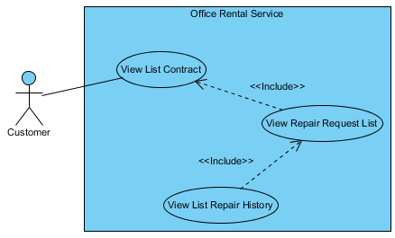

Figure ??: <Customer> View repair request list

**Use Case Specification**

|  |  |  |  |  |
| --- | --- | --- | --- | --- |
| **USE CASE – VIEW REPAIR REQUEST LIST** | | | | |
| **Use-case No.** | UC008 | **Use-case Version** | | 2.0 |
| **Use-case Name** | View repair request list | | | |
| **Author** | Trương Tiến Thành | | | |
| **Date** | 20/07/2015 | **Priority** | Normal | |
| **Actor:**   * Customer.   **Summary:**   * This use case allows customer view list repair request.   **Goal:**   * Show information about request repair of customer.   **Triggers:**   * Click “Hợp đồng của bạn” in menu bar. * Then click “Danh sách sửa chữa”.   **Preconditions:**   * User must login in customer role. * Customer at least has one contract and one request repair.   **Post Conditions:**   * **Success**: List request repair is showed successfully. * **Fail:** Cannot view list repair request.   **Main Success Scenario:**   |  |  |  | | --- | --- | --- | | Step | Actor Action | System Response | | 1 | Click “Danh sách sửa chữa” on the screen. | Show list repair request information, includes:   * Mô tả: Text. * Ngày tạo: Text. * Tìng trạng: Text. * Ngày đã sửa chữa: Text. * Lịch sử sữa chửa: Button. |   **Alternative Scenario:**   |  |  |  | | --- | --- | --- | | No. | Actor Action | System Response | |  |  |  |   **Exceptions:**   |  |  |  | | --- | --- | --- | | No. | Actor Action | System Response | |  |  |  |   **Relationships:** View list contract, view list repair history.  **Business Rules:**   * Only show request has status “Đang xử lý” and “Chờ khách hàng xác nhận”. * Can’t view repair request list of other customer. | | | | |

Table ??: <Customer> View repair request list

##### <Customer> View list repair history

**Use Case Diagram**



Figure ??: <Customer> View list repair history

**Use Case Specification**

|  |  |  |  |  |
| --- | --- | --- | --- | --- |
| **USE CASE – VIEW LIST REPAIR HISTORY** | | | | |
| **Use-case No.** | UC009 | **Use-case Version** | | 2.0 |
| **Use-case Name** | View list repair history | | | |
| **Author** | Trương Tiến Thành | | | |
| **Date** | 20/07/2015 | **Priority** | Normal | |
| **Actor:**   * Customer.   **Summary:**   * This use case allows customer view list repair history.   **Goal:**   * Show information about request repair which had repaired.   **Triggers:**   * Click “Hợp đồng của bạn” in menu bar. * Click “Danh sách sửa chữa”. * Click “Lịch sử sửa chữa”.   **Preconditions:**   * User must login in customer role. * Customer at least has one contract and one request repair.   **Post Conditions:**   * **Success**: List repair history is showed successfully. * **Fail:** Cannot view list repair history.   **Main Success Scenario:**   |  |  |  | | --- | --- | --- | | Step | Actor Action | System Response | | 1 | Click “Lịch sử sửa chữa” button. | Show list request that had repaired, includes:   * Mô tả: Text. * Ngày tạo: Text. * Tìng trạng: Text. |   **Alternative Scenario:**   |  |  |  | | --- | --- | --- | | No. | Actor Action | System Response | |  |  |  |   **Exceptions:**   |  |  |  | | --- | --- | --- | | No. | Actor Action | System Response | |  |  |  |   **Relationships:** View repair request list.  **Business Rules:**   * Show request has status “Hoàn thành” and “Hủy”. * Can’t view repair request list of other customer. | | | | |

Table ??: <Customer> View list repair history

##### <Customer> Request extend contract

**Use Case Diagram**

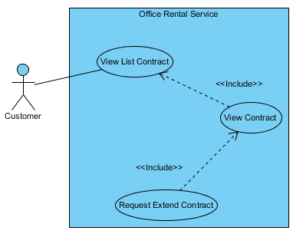

Figure ??: <Customer> Request extend contract

**Use Case Specification**

|  |  |  |  |  |
| --- | --- | --- | --- | --- |
| **USE CASE – REQUEST EXTEND CONTRACT** | | | | |
| **Use-case No.** | UC010 | **Use-case Version** | | 2.0 |
| **Use-case Name** | Request extend contract | | | |
| **Author** | Trương Tiến Thành | | | |
| **Date** | 20/07/2015 | **Priority** | Normal | |
| **Actor:**   * Customer.   **Summary:**   * This use case allows customer request extend the contract.   **Goal:**   * Customer can request extend the contract if they want to continue hiring.   **Triggers:**   * Click “Hợp đồng của bạn” in menu bar. * Click “Chi tiết”. * Then click link “Gia hạn”   **Preconditions:**   * User must login in customer role. * Customer at least has one contract.   **Post Conditions:**   * **Success**: Send request extend successfully. * **Fail:** Cannot send request extend.   **Main Success Scenario:**   |  |  |  | | --- | --- | --- | | Step | Actor Action | System Response | | 1 | Click link “Gia hạn” in line “Ngày hết hạn”. | System show [Contract extend pop-up], contain:   * Bạn đang yêu cầu gia hạn hợp đồng. Chúng tôi sẽ sớm liên lạc với bạn để xác nhận. Nhấn "Đồng ý" để xác nhận: Text. * Đồng ý: Button. * Hủy: Button. | | 2 | Click “Đồng ý” button.  [Alternative 1] | Close [Contract extend pop-up] and show message: “Đã gửi yêu cầu gia hạn hợp đồng” |   **Alternative Scenario:**   |  |  |  | | --- | --- | --- | | No. | Actor Action | System Response | | 1 | Click “Hủy” button. | Close [Contract extend pop-up] and return to [Contract detail page] |   **Exceptions:**   |  |  |  | | --- | --- | --- | | No. | Actor Action | System Response | |  |  |  |   **Relationships:** View contract.  **Business Rules:**   * After receive request, manager will contact with customer and edit contract. * If customer send request extend, they can’t send request return until manager check. | | | | |

Table ??: <Customer> Request extend contract

##### <Customer> Request return contract

**Use Case Diagram**

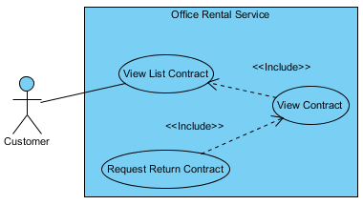

Figure ??: <Customer> Request return contract

**Use Case Specification**

|  |  |  |  |  |
| --- | --- | --- | --- | --- |
| **USE CASE – REQUEST RETURN CONTRACT** | | | | |
| **Use-case No.** | UC011 | **Use-case Version** | | 2.0 |
| **Use-case Name** | Request return contract | | | |
| **Author** | Trương Tiến Thành | | | |
| **Date** | 20/07/2015 | **Priority** | Normal | |
| **Actor:**   * Customer.   **Summary:**   * This use case allows customer request return the contract.   **Goal:**   * Customer can request return the contract if they want to stop hiring.   **Triggers:**   * Click “Hợp đồng của bạn” in menu bar. * Click “Chi tiết”. * Then click link “Hủy hợp đồng trước hạn”   **Preconditions:**   * User must login in customer role. * Customer at least has one contract.   **Post Conditions:**   * **Success**: Send request return successfully. * **Fail:** Cannot send request return.   **Main Success Scenario:**   |  |  |  | | --- | --- | --- | | Step | Actor Action | System Response | | 1 | Click link “Trả trước hạn” in line “Ngày hết hạn”. | System show [Contract return pop-up], contain:   * Bạn đang yêu cầu hủy hợp đồng trước hạn. Chúng tôi sẽ liên lạc với bạn để xác nhận và bàn giao văn phòng trong thời gian sớm nhất. Nhấn "Đồng ý" để xác nhận: Text. * Đồng ý: Button. * Hủy: Button. | | 2 | Click “Đồng ý” button.  [Alternative 1] | Close [Contract return pop-up] and show message: “Đã gửi yêu cầu hủy hợp đồng trước hạn”. |   **Alternative Scenario:**   |  |  |  | | --- | --- | --- | | No. | Actor Action | System Response | | 1 | Click “Hủy” button. | Close [Contract return pop-up] and return to [Contract detail page] |   **Exceptions:**   |  |  |  | | --- | --- | --- | | No. | Actor Action | System Response | |  |  |  |   **Relationships:** View contract.  **Business Rules:**   * After staff contact with customer to check the office, manager accept the request. * If customer send request return, they can’t send request extend until manager check. | | | | |

Table ??: <Customer> Request return contract

##### <Customer> View list contract

**Use Case Diagram**

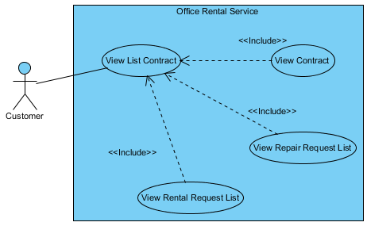

Figure ??: <Customer> View list contract

**Use Case Specification**

|  |  |  |  |  |
| --- | --- | --- | --- | --- |
| **USE CASE – VIEW LIST CONTRACT** | | | | |
| **Use-case No.** | UC012 | **Use-case Version** | | 2.0 |
| **Use-case Name** | View list contract | | | |
| **Author** | Trương Tiến Thành | | | |
| **Date** | 20/07/2015 | **Priority** | Normal | |
| **Actor:**   * Customer.   **Summary:**   * This use case allows customer view list contract.   **Goal:**   * Show information about contract of customer.   **Triggers:**   * Click “Hợp đồng của bạn” in menu bar.   **Preconditions:**   * User must login in customer role. * Customer at least has one contract.   **Post Conditions:**   * **Success**: List contract is showed successfully. * **Fail:** Cannot view list contract.   **Main Success Scenario:**   |  |  |  | | --- | --- | --- | | Step | Actor Action | System Response | | 1 | Click “Hợp đồng của bạn” in menu bar. | Show list contract information, includes:   * Tên văn phòng: Text. * Ngày bắt đầu: Text. * Ngày kết thúc: Text. * Giá (VNĐ): Text. * Thời hạn thanh toán: Text. * Chi tiết: Button. * Danh sách sửa chữa: Button. * Danh sách thuê thiết bị: Button. |   **Alternative Scenario:**   |  |  |  | | --- | --- | --- | | No. | Actor Action | System Response | |  |  |  |   **Exceptions:**   |  |  |  | | --- | --- | --- | | No. | Actor Action | System Response | |  |  |  |   **Relationships:** View contract, view rental request list, view repair request list  **Business Rules:**   * Only show list contract of customer who is logging. | | | | |

Table ??: <Customer> View rental request list

##### <Customer> View contract

**Use Case Diagram**

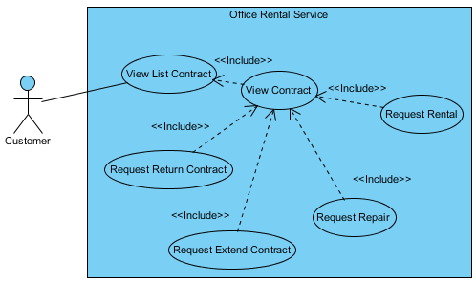

Figure ??: <Customer> View contract

**Use Case Specification**

|  |  |  |  |  |
| --- | --- | --- | --- | --- |
| **USE CASE – VIEW CONTRACT** | | | | |
| **Use-case No.** | UC013 | **Use-case Version** | | 2.0 |
| **Use-case Name** | View contract | | | |
| **Author** | Trương Tiến Thành | | | |
| **Date** | 20/07/2015 | **Priority** | Normal | |
| **Actor:**   * Customer.   **Summary:**   * This use case allows customer view detail contract.   **Goal:**   * Show information about contract of customer.   **Triggers:**   * Click “Hợp đồng của bạn” in menu bar. * Click “Chi tiết” button.   **Preconditions:**   * User must login in customer role. * Customer at least has one contract.   **Post Conditions:**   * **Success**: Contract information is showed successfully. * **Fail:** Cannot view list contract.   **Main Success Scenario:**   |  |  |  | | --- | --- | --- | | Step | Actor Action | System Response | | 1 | Click “Chi tiết” in the screen. | Show contract information, includes:   * Tên văn phòng: Text. * Yêu cầu sửa chữa: Link. * Ngày bắt đầu: Text. * Ngày hết hạn: Text. * Hủy hợp đồng trước hạn: Link. * Gia hạn hợp đồng: Link * Điều khoản giá: Text. * Danh sách thuê tết bị hiện tại:   Tên thiết bị: Text.  Mô tả: Text.  Giá thuê (VNĐ): Text.  Số lượng (cái): Text.  Thành tiền (VNĐ): Text.  Tổng cộng (VNĐ): Text.   * Yêu câu thuê thiết bị: Button. |   **Alternative Scenario:**   |  |  |  | | --- | --- | --- | | No. | Actor Action | System Response | |  |  |  |   **Exceptions:**   |  |  |  | | --- | --- | --- | | No. | Actor Action | System Response | |  |  |  |   **Relationships:** Request extend contract, request return contract, request repair, request rental, view list contract.  **Business Rules:**   * Can’t view contract of other customer. * If contract expire, customer can’t view it. | | | | |

Table ??: <Customer> View rental request list

##### <Customer> Request repair

**Use Case Diagram**

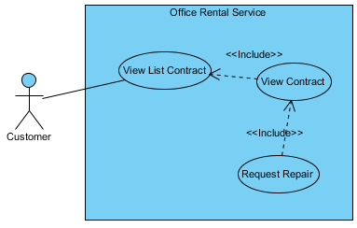

Figure ??: <Customer> Request repair

**Use Case Specification**

|  |  |  |  |  |
| --- | --- | --- | --- | --- |
| **USE CASE – REQUEST REPAIR** | | | | |
| **Use-case No.** | UC014 | **Use-case Version** | | 2.0 |
| **Use-case Name** | Request repair | | | |
| **Author** | Trương Tiến Thành | | | |
| **Date** | 20/07/2015 | **Priority** | Normal | |
| **Actor:**   * Customer   **Summary:**   * This use case allows customer to send request repair.   **Goal:**   * Customer can send request repair.   **Triggers:**   * Click “Hợp đồng của bạn” in menu bar. * Click “Chi tiết” button. * Then click “Yêu cầu sửa chữa” link.   **Preconditions:**   * User must login in customer role. * Customer at least has one contract.   **Post Conditions:**   * **Success**: Request repair is sent successfully. * **Fail:** Cannot send request repair.   **Main Success Scenario:**   |  |  |  | | --- | --- | --- | | Step | Actor Action | System Response | | 1 | Click “Yêu cầu sửa chữa” link on the screen. | Show [Request repair page], includes:   * Tên văn phòng: Text. * Sữa chữa: List checkbox. * Mô tả yêu cầu sửa chữa: Text area.   [Exception 1]   * Gửi yêu cầu: Button.   [Exception 2]   * Hủy: Button. | | 2 | Click “Gửi” button on screen.  [Alternative 1] | Show message “Thành công. Đã gửi yêu cầu sửa chữa” and return to [Contract list page]. |   **Alternative Scenario:**   |  |  |  | | --- | --- | --- | | No. | Actor Action | System Response | | 1 | Click “Hủy” button. | Return to [Contract list page]. |   **Exceptions:**   |  |  |  | | --- | --- | --- | | No. | Actor Action | System Response | | 1 | “Mô tả yêu cầu sửa chữa” is empty. | Show error message: “Vui lòng điền mô tả”. | | 2 | Not click checkbox in “Sửa chữa”. | Show error message: “Vui lòng chọn ít nhất một tiện nghi để sửa”. |   **Relationships:** View contract  **Business Rules:**   * Status of request repair is “Chờ xử lý”. | | | | |

Table ??: <Customer> Request repair

##### <Customer> Request rental

**Use Case Diagram**

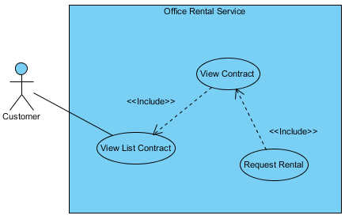

Figure ??: <Customer> Request repair

**Use Case Specification**

|  |  |  |  |  |
| --- | --- | --- | --- | --- |
| **USE CASE – REQUEST REPAIR** | | | | |
| **Use-case No.** | UC015 | **Use-case Version** | | 2.0 |
| **Use-case Name** | Request repair | | | |
| **Author** | Trương Tiến Thành | | | |
| **Date** | 20/07/2015 | **Priority** | Normal | |
| **Actor:**   * Customer   **Summary:**   * This use case allows customer to send request rental.   **Goal:**   * Customer can choose rental item and send request rental.   **Triggers:**   * Click “Hợp đồng của bạn” in menu bar. * Click “Chi tiết” button. * Then click “Yêu cầu thuê thiết bị” link.   **Preconditions:**   * User must login in customer role. * Customer at least has one contract.   **Post Conditions:**   * **Success**: Request rental is sent successfully. * **Fail:** Cannot send request rental.   **Main Success Scenario:**   |  |  |  | | --- | --- | --- | | Step | Actor Action | System Response | | 1 | Click “Yêu cầu thuê thiết bị” button on the screen. | Show [Rental item page], includes:   * Xem giỏ hàng: Button. * Số lượng: Number (> 0).   [Exception 1]   * Thuê: Button. | | 2 | Choose quantity of the item you want to hire.  Click “Thuê” button on screen. | List item will update on left screen. | | 3 | Click “Xem giỏ hàng” button. | Redirect to [Request rental page]. | | 4 | Click “Gửi yêu cầu” button. | Show message “Gửi yêu cầu thành công” and redirect to [Home page]. |   **Alternative Scenario:**   |  |  |  | | --- | --- | --- | | No. | Actor Action | System Response | |  |  |  |   **Exceptions:**   |  |  |  | | --- | --- | --- | | No. | Actor Action | System Response | | 1 | Input number > 0 |  |   **Relationships:** View contract  **Business Rules:**   * Status of request rental is “Chờ xử lý”. | | | | |

Table ??: <Customer> Request rental